Programming Paradigms

📌 Definition:
# Source: AI Source: Provided by: [Data Path: Persons Table -> ID Column: 1, Name_En Column: Motasem Essam] -> From: [Chatgpt (GPT‑5 Mini)] on [12/9/2025]
A programming paradigm is a style or approach to writing and organizing code.
It defines how you structure programs and solve problems using a programming language.

🧠 Simple idea:
# Source: AI Source: Provided by: [Data Path: Persons Table -> ID Column: 1, Name_En Column: Motasem Essam] -> From: [Chatgpt (GPT‑5 Mini)] on [12/9/2025]
Paradigm = “Way of thinking in programming” 💡

🔍 Why programming paradigms matter:
# Source: AI Source: Provided by: [Data Path: Persons Table -> ID Column: 1, Name_En Column: Motasem Essam] -> From: [Chatgpt (GPT‑5 Mini)] on [12/9/2025]
- 🧩 Help organize code clearly
- ⚙️ Influence how problems are solved
- 🔄 Affect readability and maintainability
- 🧠 Shape the design of programming languages

🧩 Common Programming Paradigms:

🔄 Procedural Programming
# Source: AI Source: Provided by: [Data Path: Persons Table -> ID Column: 1, Name_En Column: Motasem Essam] -> From: [Chatgpt (GPT‑5 Mini)] on [12/9/2025]
- Focuses on step-by-step instructions
- Uses procedures (functions)
👉 Examples: C, Pascal

🧠 Object-Oriented Programming (OOP)
# Source: AI Source: Provided by: [Data Path: Persons Table -> ID Column: 1, Name_En Column: Motasem Essam] -> From: [Chatgpt (GPT‑5 Mini)] on [12/9/2025]
- Organizes code into objects (data + behavior)
- Uses concepts like:
  - Encapsulation
  - Inheritance
  - Polymorphism
👉 Examples: Java, C++, Python

🔁 Functional Programming
# Source: AI Source: Provided by: [Data Path: Persons Table -> ID Column: 1, Name_En Column: Motasem Essam] -> From: [Chatgpt (GPT‑5 Mini)] on [12/9/2025]
- Focuses on functions and immutability
- Avoids changing data
👉 Examples: Haskell, Scala

📜 Declarative Programming
# Source: AI Source: Provided by: [Data Path: Persons Table -> ID Column: 1, Name_En Column: Motasem Essam] -> From: [Chatgpt (GPT‑5 Mini)] on [12/9/2025]
- Focuses on what to do, not how to do it
- Less control flow, more expression of logic
👉 Examples:
- SQL 🗄️
- HTML 🏷️
- CSS 🎨

⚡ Event-Driven Programming
# Source: AI Source: Provided by: [Data Path: Persons Table -> ID Column: 1, Name_En Column: Motasem Essam] -> From: [Chatgpt (GPT‑5 Mini)] on [12/9/2025]
- Program reacts to events (user actions, system triggers)
- Common in UI and web apps
👉 Examples: JavaScript (browser events)

🆚 Quick Comparison:
# Source: AI Source: Provided by: [Data Path: Persons Table -> ID Column: 1, Name_En Column: Motasem Essam] -> From: [Chatgpt (GPT‑5 Mini)] on [12/9/2025]
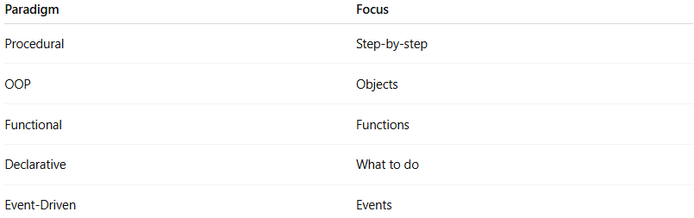
Paradigm | Focus
Procedural | Step-by-step
OOP | Objects
Functional | Functions
Declarative | What to do
Event-Driven | Events

🎯 Summary:
# Source: AI Source: Provided by: [Data Path: Persons Table -> ID Column: 1, Name_En Column: Motasem Essam] -> From: [Chatgpt (GPT‑5 Mini)] on [12/9/2025]
Programming paradigms are different styles of writing code that guide how we design and solve problems in software development.

